Research-Based, Child-Centered Parenting Plans:
The Interface between the Family and the Law

QUALITY OF CO-PARENTING MATTERS
The question is not whether divorcing parents will co-parent, the question is how skillfully will they co-parent? Will parents want to fight for their individual parental rights, or can we shift them to fight for what's best for their children? What's best for kids? "Good-enough" parents caring for and engaged in their children's lives.
What can we be sure harms children over time?
- Parental alienation (inadvertent or direct)
- On-going high-conflict/toxic stress (emotional and nervous system impacts)
- Getting caught in the middle (loyalty binds)
- Losing a parent (emotionally or physically)
Interventions should be directed at mitigating the above in the most expeditious manner.
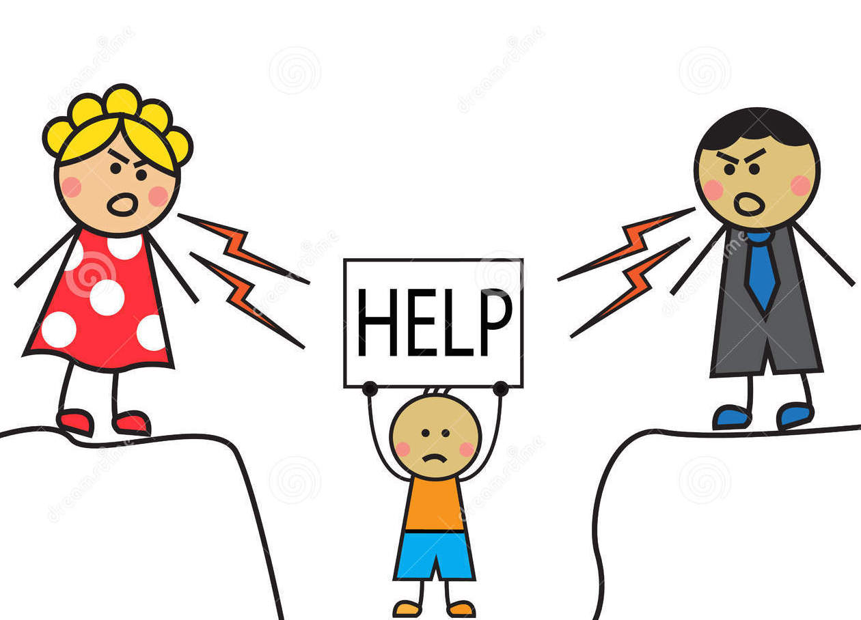

Children do not need "perfect parents," nor do they need more contact with the better parent ... they need on-going, secure relationships with both good-enough parents. That said, basic parenting skills are particlarly important to assist chidlren through the stress, change and loss of divorce as the family restructures. Divorce often temporarily changes good-enough parents' parenting style. You may find that basically good parents polarize with one another under significant stress: one parent becomes permissive and overly protective of the children, while the other becomes more authoritarian and intolerant. Professionals and courts can inadvertently make this polarity stronger by siding with one parent against the other, and consequently disadvantaging kids. Parents need help to do what's required to strengthen their "Authoritative" parenting skills during and after divorce.

