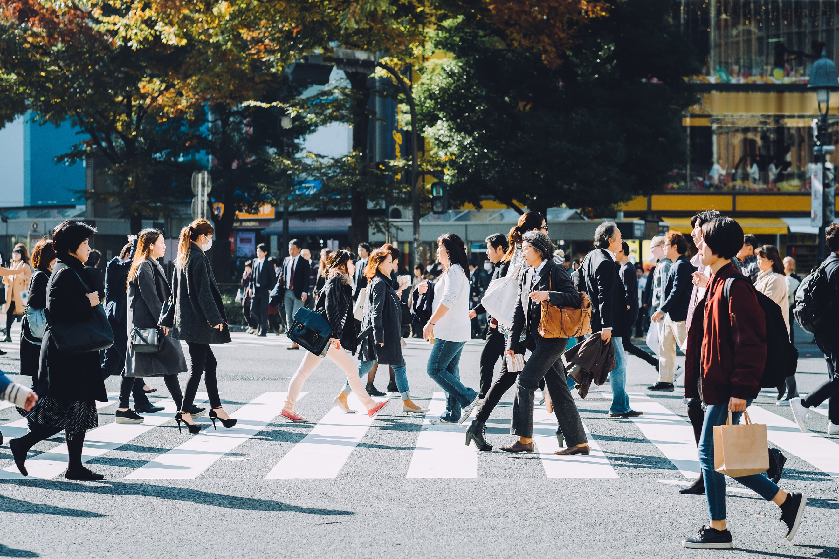
Building a Client Base and Intake Procedures
- Referring a Case to a Team- Who and How? Intake and screening.
___________________________________________
___________________________________________
___________________________________________
___________________________________________

- Who is your target client? What are the challenges of this population? (Resources, location, capacity, DEI, remote or not?)

___________________________________________
___________________________________________
___________________________________________
___________________________________________

- How do you make the connections between client and team?

___________________________________________
___________________________________________
___________________________________________
___________________________________________

- Marketing plan – social media, court connections, attorney and MHP and FP, other resources to include?

___________________________________________
___________________________________________
___________________________________________
___________________________________________

- Community organization to include as partners for referrals?

___________________________________________
___________________________________________
___________________________________________
___________________________________________

- Roadblocks to building a client base? Other attorneys, court structures, time, energy and
money?

___________________________________________
___________________________________________
___________________________________________
___________________________________________

- Growing and maintaining the connections?

___________________________________________
___________________________________________
___________________________________________
___________________________________________

- Closing the case – who and how in court and financially?

___________________________________________
___________________________________________
___________________________________________
___________________________________________

