What am I aware of?

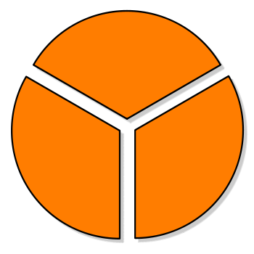

What am I feeling?

What do I want?

What Am I Thinking?